STRIKE Lesson: “I Statements”
Adapted from “Conflict Resolution Activities for Secondary Students”

SEL Standard: Relationship Skills
STRIKE Focus: Empathy
Objective: Students will develop skill in using “I Statements.”
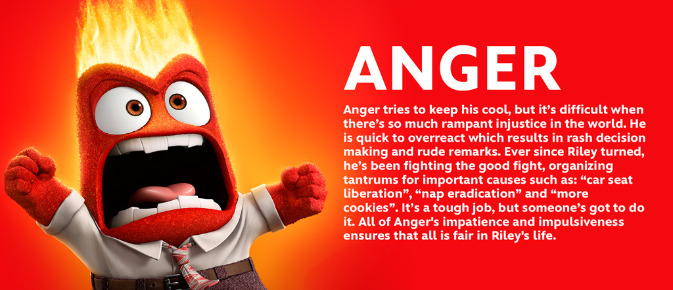
Procedure:
1. Today we are going to learn about “I statements.” No one would disagree that listening is important. We would also agree that it is important to get others to listen, particularly when you are angry. An “I statement” is an effective way to get someone to listen to you.
2. I statement formula
I feel _________________ when you ________________________ because _______________.

Example: I feel upset when you don’t show up for class because I want you to contribute to the group project.

3. Brainstorm synonyms for anger. Some examples are:
Aggravated appalled enraged incensed offended resentful
Annoyed disgusted exasperated infuriated repulsed steamed
Bitter dismayed frustrated irritated revolted troubled
Cranky horrified furious outraged ticked off upset
Riled nauseated hostile provoked wary vicious

4. What are some situations when you have felt angry at another person (friend, family member, boy/girlfriend, teacher). How did you handle it? Write an “I statement” using a synonym for anger about your situation.

5. Working with a partner, practice using the “I statement” formula to express how you feel with given scenarios.

6. Ask for volunteers to share their “I statements.”

------------------------------------------------------------------------------------------------------------------------------------------

Scenarios

Your friend has promised to meet you in front of the local shopping center a half hour ago. This friend is always late, and you’ve had it. Here comes the friend, looking as if he or she has all the time in the world. You are really annoyed.

Your girlfriend/boyfriend also seems to be flirting with other people at school. She/he hardly seems to pay attention to you and it’s getting very aggravating.

Every time you take a math test Chase develops cross-eyed vision. Chase’s eyes always wander over to your paper. And now Chase has the nerve to ask to look at your math homework before class. You just know Chase will simply copy it.

Jody is simply jealous. Jody told the group that you cheated and went out with someone else behind Sam’s back, and it isn’t true. Jody said terrible things about you, and you are going to talk to Jody right now!

Mom is always picking out your clothes, and she doesn’t have any idea about what’s cool. You really wish she’d quit doing this to you.

For the third time in a month your sister has borrowed a shirt from your closet without asking. This business is getting old.

