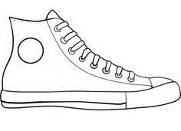
If you walked in my shoes, you would know…

