How to Print Students i-Ready Diagnostic Growth Results
- Log in to i-Ready and click on Reports.
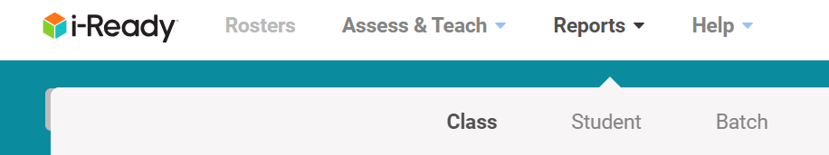
- In the dropdown menu click on Batch
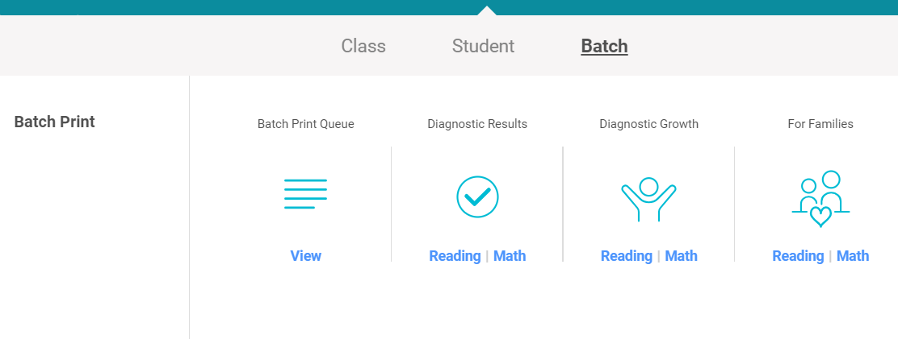
- In the dropdown menu click on Diagnostic Growth Math or Reading
- From the dropdown menu select class

- Select advisory from below
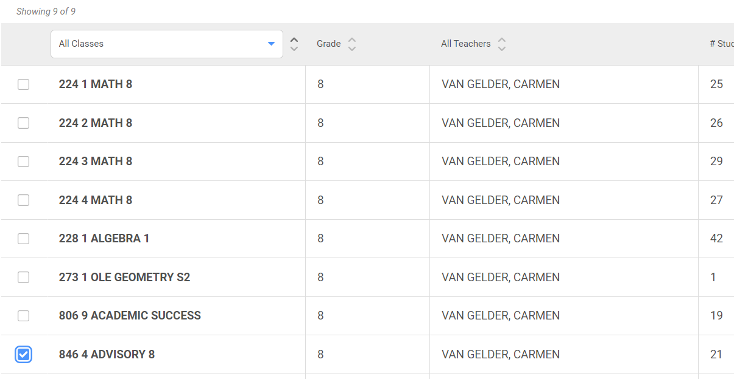
- Select print from upper right corner
- Select the other subject from upper left corner
- Select advisory form below
- Select print from upper right corner
- To get to batch print queue click on reports on very top
- Select Batch again
- Select Batch Print Queue
- Print the PDF’s of both.
